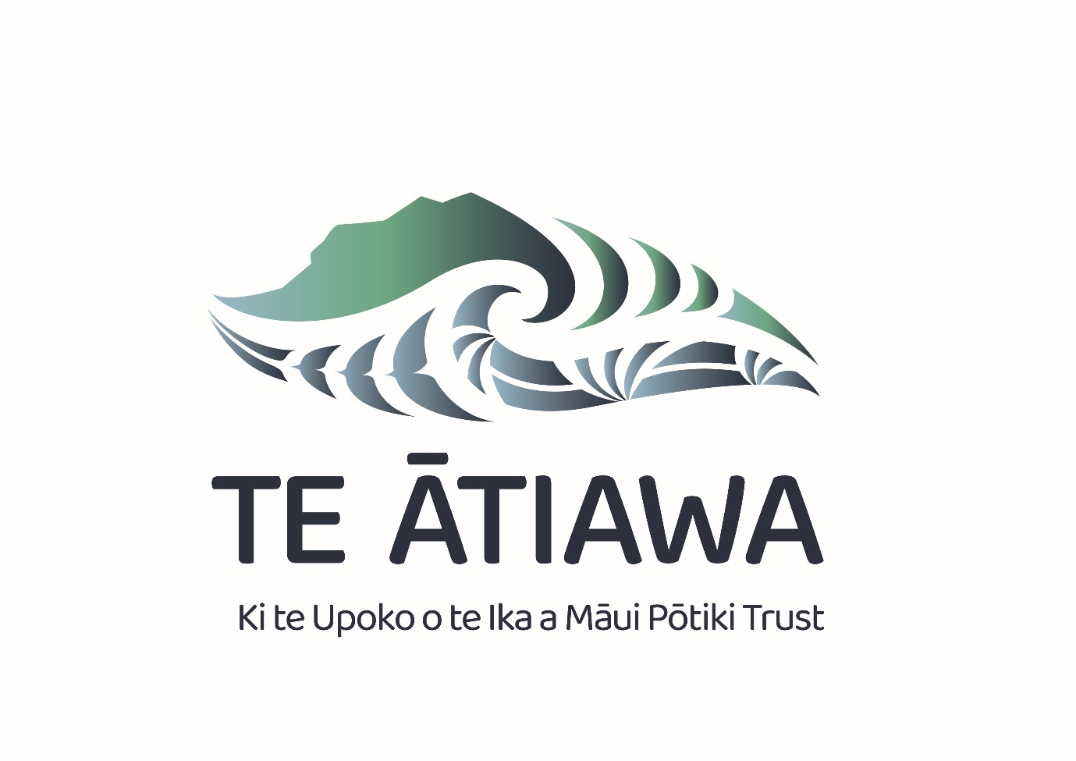 FIVE YEAR STRATEGIC pLAN

2025 - 2030

DRAFT

Logo Whakapapa

Te Ātiawa ki te Upoko o te Ika a Māui Pōtiki Trust Group consists of charitable entities which benefit from Ātiawa Nui Tonu Fisheries Limited.

These benefits extend to the wider community and the three marae; Waiwhetū, Pipitea and Te Tatau o te Pō.

This knowledge has been encapsulated into the whenua and moana surrounding the Whanganui a Tara region.

Mai i enei hinonga tarahiti e rua ka ora te iwi.

*From these two trust entities the people prosper.*

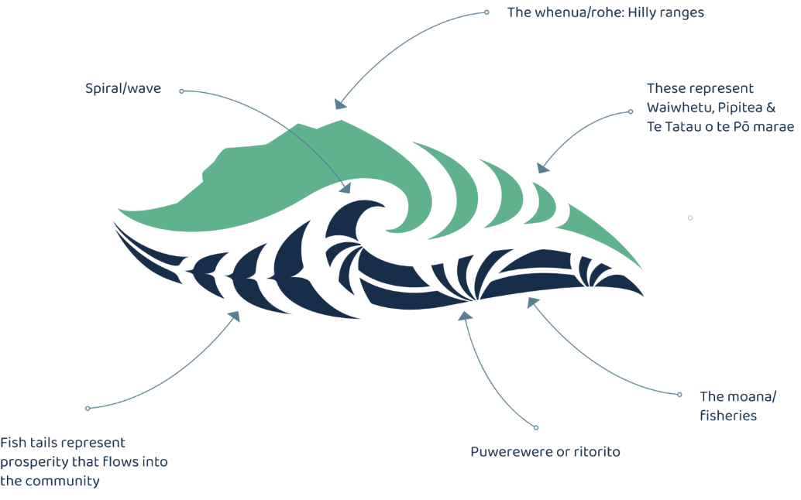

**The Trust is committed to ensure its members are involved and as such it is important that members are consulted for their input into the Strategic Plan. There is a survey form that members can provide their korero on what the Strategic Plan should refer to and contain.**

**You do not have to include your name unless you would like to.**

**Your input is invaluable to the development of the Strategic Plan.**

**Please click on the QR code for the direct link to this survey.**



**Contents**

Te Kaupapa | Mission 1

Te Huapae | Vision 1

Ngā Mātāpono | Values 1

Toitū te moana 1

Kaitiaki taonga 1

He ngākau pono 1

He ringa atawhai 1

Strategic Goals 2

Strategic Goals Objectives 3

Tangata 3

Environment 4

Organisation 4

Growth 6

How we do what we do. 7

The purpose of having a Strategic Plan. 7

Our strategic priorities and focus areas for the next five years. 7

# **Te Kaupapa | Mission**

**Kia tipu te oranga o Te Ātiawa ki te Upoko o te Ika.**

*Creating prosperity for the uri of Te Ātiawa ki te Upoko o te Ika.*

# **Te Huapae | Vision**

**Mēnā kei te ora ngā moana, ngā awa, ngā roto me te whenua, ka pērā anō tō tātou iwi.**

*If the oceans, the rivers, the lakes and the land are healthy, so too will our people be..*

# **Ngā Mātāpono | Values**

## **Toitū te moana**

*We actively protect and are committed to sustainable fisheries.*

## **Kaitiaki taonga**

*We are stewards of our assets.*

## **He ngākau pono**

*We act with humility, integrity, and honesty.*

## **He ringa atawhai**

*We support our people.*

# Strategic Goals

|  |  |  |  |  |  |  |  |
| --- | --- | --- | --- | --- | --- | --- | --- |
| **Tangata** | Forge strong and dynamic relationships across the iwi | Communicate effectively with all of our people | | Create education pathways and opportunities | | | Share value with our people and marae |
| **Environment** | Promote and protect our waterbodies and whenua | | | | Promote and protect our wider eco systems including native flora and fauna | | |
| **Organisation** | Develop our people and continue to grow capability of our organisation at all levels | | Apply best practice organisational structures, processes and policies | | | Strengthen the position of Te Ātiawa ki te Upoko o te Ika a Māui Pōtiki through strategic partnering | |
| **Growth** | Set and achieve growth targets to deliver optimal long term economic benefits | | Identify, evaluate and action new opportunities for economic growth. | | | Grow the financial knowledge of our organisation | |

# Strategic Goals Objectives

|  |  |  |  |
| --- | --- | --- | --- |
| Tangata | | | |
| **Goals** | **Objective 1** | **Objective 2** | **Objective 3** |
| Forge strong and dynamic relationships across the iwi. |  |  |  |
| Communicate effectively with all of our people |  |  |  |
| Create education pathways and opportunities |  |  |  |
| Share value with our people and marae |  |  |  |

|  |  |  |  |
| --- | --- | --- | --- |
| Environment | | | |
| **Goals** | **Objective 1** | **Objective 2** | **Objective 3** |
| Promote and protect our waterbodies and whenua |  |  |  |
| Promote and protect our wider eco systems including native flora and fauna |  |  |  |

|  |  |  |  |
| --- | --- | --- | --- |
| Organisation | | | |
| **Goals** | **Objective 1** | **Objective 2** | **Objective 3** |
| Develop our people and continue to grow capability of our organisation at all levels |  |  |  |
| Organisation ………. continued | | | |
| **Goals** | **Objective 1** | **Objective 2** | **Objective 3** |
| Apply best practice organisational structures, processes and policies |  |  |  |
| Strengthen the position of Te Ātiawa ki te Upoko o te Ika a Māui Pōtiki through strategic partnering |  |  |  |

|  |  |  |  |
| --- | --- | --- | --- |
| Growth | | | |
| **Goals** | **Objective 1** | **Objective 2** | **Objective 3** |
| Set and achieve growth targets to deliver optimal long term economic benefits |  |  |  |
| Identify, evaluate and action new opportunities for economic growth. |  |  |  |
| Grow the financial knowledge of our organisation |  |  |  |

# 

# How we do what we do.

Our core guiding principles are: To practise and uphold rangatiratanga and kaitiakitanga. To build and grow our resource base whilst adopting a carefully considered approach towards risk. To maintain and forge new relationships & partnerships.

# The purpose of having a Strategic Plan.

To communicate a shared vision to Te Ātiawa uri in Te Whanganui a Tara. To inform resource allocation and decision making by identifying where the most value can be created. To keep us on track with our vision and in a strong position from which we can adapt to a changing environment.

# Our strategic priorities and focus areas for the next five years.

1. Mana Tūpuna – Preserve, maintain, enhance and honour our whakapapa and tūpuna.
2. Mana Moana – Promote, advance and assert our mana moana and te mana o te wai.
3. Mana Whenua – Protect and safeguard our coastal, riverside and lakeside lands.
4. Pūtea Investment - Invest to create opportunities.
5. Mana Tangata - Lead & support whanau ora.
6. Governance - Be a highly professional governance body.

Ngā mihi

